Rounds 1 - 3

B

A

9 feet

10 feet

9 feet

13.5 feet

30 feet

9 feet

30 feet

18 feet

5.5 feet

1.25 feet

11 feet

3.5 feet

33 feet

12 feet

**A**

12 feet

**BN**

2.5 feet

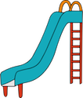

43 feet

40 feet

8.5 feet

8.5 feet

17 feet

4.5 feet

B

6.5 feet

4.5 feet

10 feet

A